Circuit Diagram:

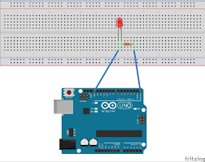

**Concept used:** The experiment was to set up a simple circuit with an LED that blinks according to instructions upload to the arduino board.

**Learning and Observation:** Turns on an LED on for one sec, then off for one second, and so on. We use pin 13 because depending o our arduino board, it has either a built in Led or a built in resistor so that we need only an LED.

**Precautions:**

1. Connections should not be loose.

2. Check the led before using it.

3. Never connect a led directly to a power supply.

**Learning outcomes:**

1. The concept of arduino.

2. Blink led with arduino.

3. The arduino hardware and software